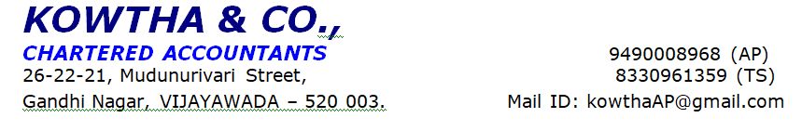
Sl | Branch Name | ANANTAPUR
1 | Application Reference No. | 8705197
2 | Applicant Name | MR. XXXX
3 | Applicant Office Address | XXX
4 | Person Met - Name, Designation & Mobile No | APPLICANT , PROPRIETOR, XXX
5 | Personal Information:
a | Details of family members name, age and occupation: (pls tick on dependents) | His family consists of two members applicant himself, MrsXXX-spouse (H/w) 50 Yrs, Mr. XXX (27 Yrs), Son.
b | Residence Address | XXX
c | whether self owned/parental/rented | Owned
d | Area of the house property and estimated market value | Own house in Adilabad
e | No. of Years at same Residence | By Birth
f | No. of years in same city | By Birth
g | Permanent Address | -
h | Details of other owned property in the city | -
i | Any other source of income apart from this business | NA
6 | Business Information
a | Name of Business | M/S. XXX
b | Nature of Business | Manufacturing of silk saree
c | Constitution | PROPRIETORSHIP
d | Name of Partners/Directors and share % | NA
e | Type of Customer | General public, retail and wholesale shops
f | Stability in same business - No of Years | 25 years
g | Whether the stability was verified by any Registration certificate / distribution / dealership letter displayed in shop / office / Factory | YES
h | Family Structure involved in Business | NA
I | Business Premises whether owned or rented | Owned
J | Actual monthly sales/Receipts as per Customer | Rs. 30,00,000/- per month.
K | What % sales is done on credit | NIL
L | Manufacturing process / Trading details | Manufacturing and Trading
M | Whether sales concentration is >50% on one party. If yes name of Party and contact no | NO
N | Business Cycle -How many days credit allowed to Debtors and what are actual debtors amount as on date | -
O | Business Cycle - How many days credit allowed by creditors to CM and what are actual Creditors amount as on date | -
P | Business Cycle – What is stock valuation as on date | -
Q | Gross & Net margins % in Business | 8.33 %
R | Monthly Net saving after all expenses in Rs | 2.5 LAKHS
S | Name and contact no of two major suppliers
T | Name and contact no of two major buyers | -
U | No of Employees | 02 Members
V | Name board seen if yes what was written | No Name board was observed at Business Premises.
W | Locality of Business/Office | Office
X | Whether Residence cum office set up | No
Y | Applicability of VAT / Excise / Service tax and rate of same | -
Z | Latest Qtr VAT return value/Service tax paid | -
7 | Environmental and Social Safeguards (ESS)
a. | Is the entity involved in any commercial pest control operation, use any Ozone depleting substance, hazardous chemicals, bio medical waste, Dyes, forest products, tobacco, alcohol, weapons, gambling, radioactive materials, unbounded asbestos, harmful fishing practice, commercial logging. | NO
b. | Does the entity involve in Child or forced Labour or business involve displacement of people, impact on indigenous people or established in land designated as forest or forest products | NO
c. | Does the entity have required consent of establishment from State pollution control board and other government authorities on establishment in Wetland Area, near National Park, Sanctuaries or Forest areas, ASI certificate for establishment up to 300 meters near a protected monument or cultural heritage, 500 meters near Coastal Regulation Zone | NO
d. | Does the entity involves in proper mechanism for treatment or disposal of waste and does not emit air, water or noise pollutants. | NO
e. | Does the Entity comply with the above ESS guidelines | NO
Others:
Existing Loan Details

Type of Loan | Bank Name | Loan Amt | EMI | Tenure remaining
BL | City Union Bank | Rs. 8,00,000/- | Rs. 28,000/-
B | Banking Details :-
 | Bank Name1 – City Union Bank
 | Account Type – Current Account
 | Vintage of account –
 | If CC/OD limit- what is limit – Min Bal | NA
c | Customer Behavior | Good
8 | Detailed purpose/End use of Loan Amount | Applied loan amount Rs.30,00,000/- for Business development
9 | Detailed observations (Positive and Negative) | Business Details :-  “M/S. XXX '' started in the year 2000 by the Applicant XXX. Have overall experience of 25 years in this field.  Business Details:-  - Applicant started the business in the year of 2000.  - It is sole proprietorship business and applicant is the sole proprietor of business.  - He is running his business under the name of M/S. XXX  - The Business was registered under GST in 2017.  - He has 25 years of experience in this field  - Nature of the business is manufacturing of Silk sarees  - He supplies material to power loom and handloom owner  - He pays Rs. 10,000/- to Rs. 40,000/- per saree for handloom and Rs.1, 500/- to Rs. 10,000/- per saree for power loom owner.  - He purchases raw material from surath, Siddlagattla etc.,  - He sold saree to all over Telangana, Andhra Pradesh, Tamilnadu, Karnataka  - Customers are wholesale shops, retail shops and general public.  - At present he has Rs. 1,25,00,000/- worth of stock and Rs. 25,00,000/- worth of raw material at business premises.  - He is running business in own premises.  - 03 employees are working under him and paying the salaries amount of Rs. 50,000/- per month.  - Major business transactions are done through cash/ bank and bank in his business.  - He has provided GST, ITR’S, Labor License, bank statement and Electricity bill.  Concerns:-
10 | Status of PD | Positive
11 | PD conducted by:
 | Name : HARISH | Designation : PD Executive
 | Signature : | 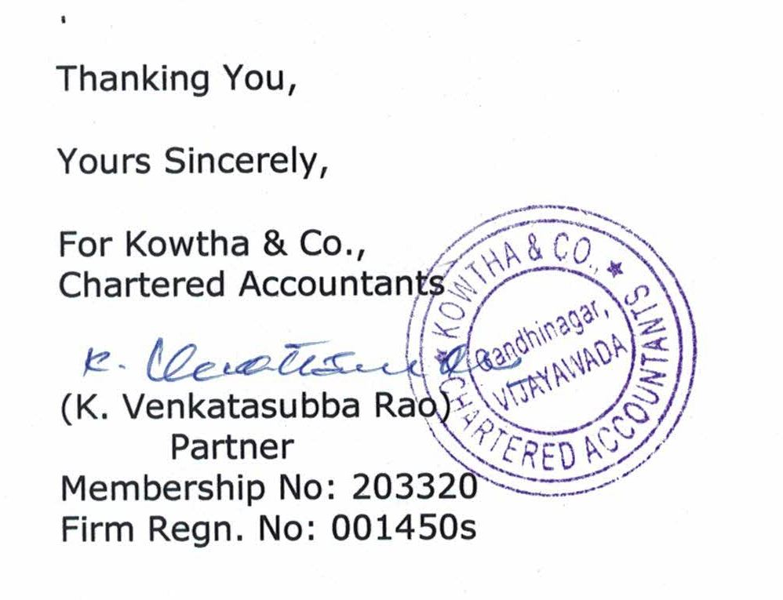
 | Date: 09-05-2025 | Time : 02:20 PM

Photo:

